Azure Setup & .NET API Foundations
- .NET Web API development (Banking APIs)
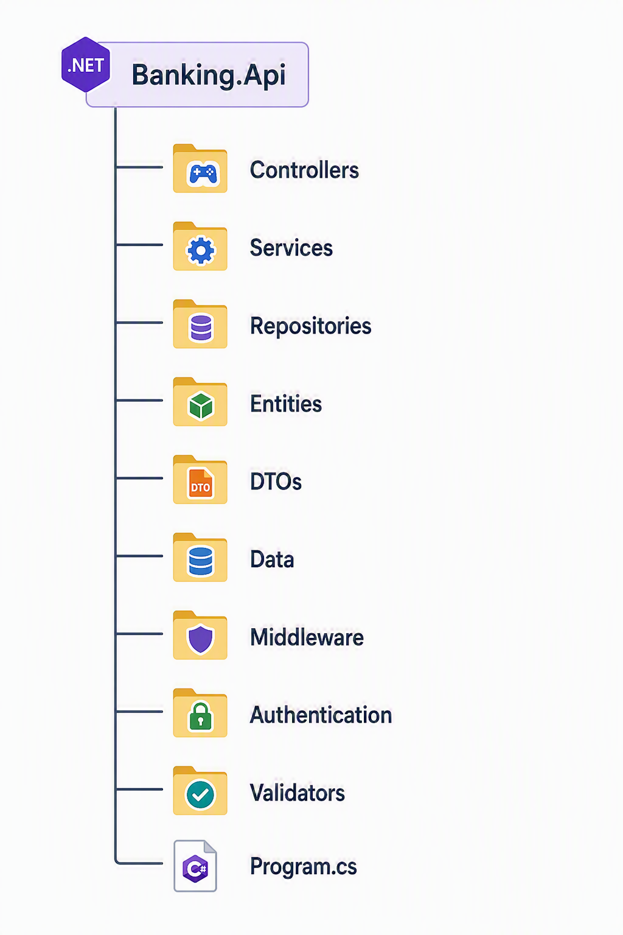
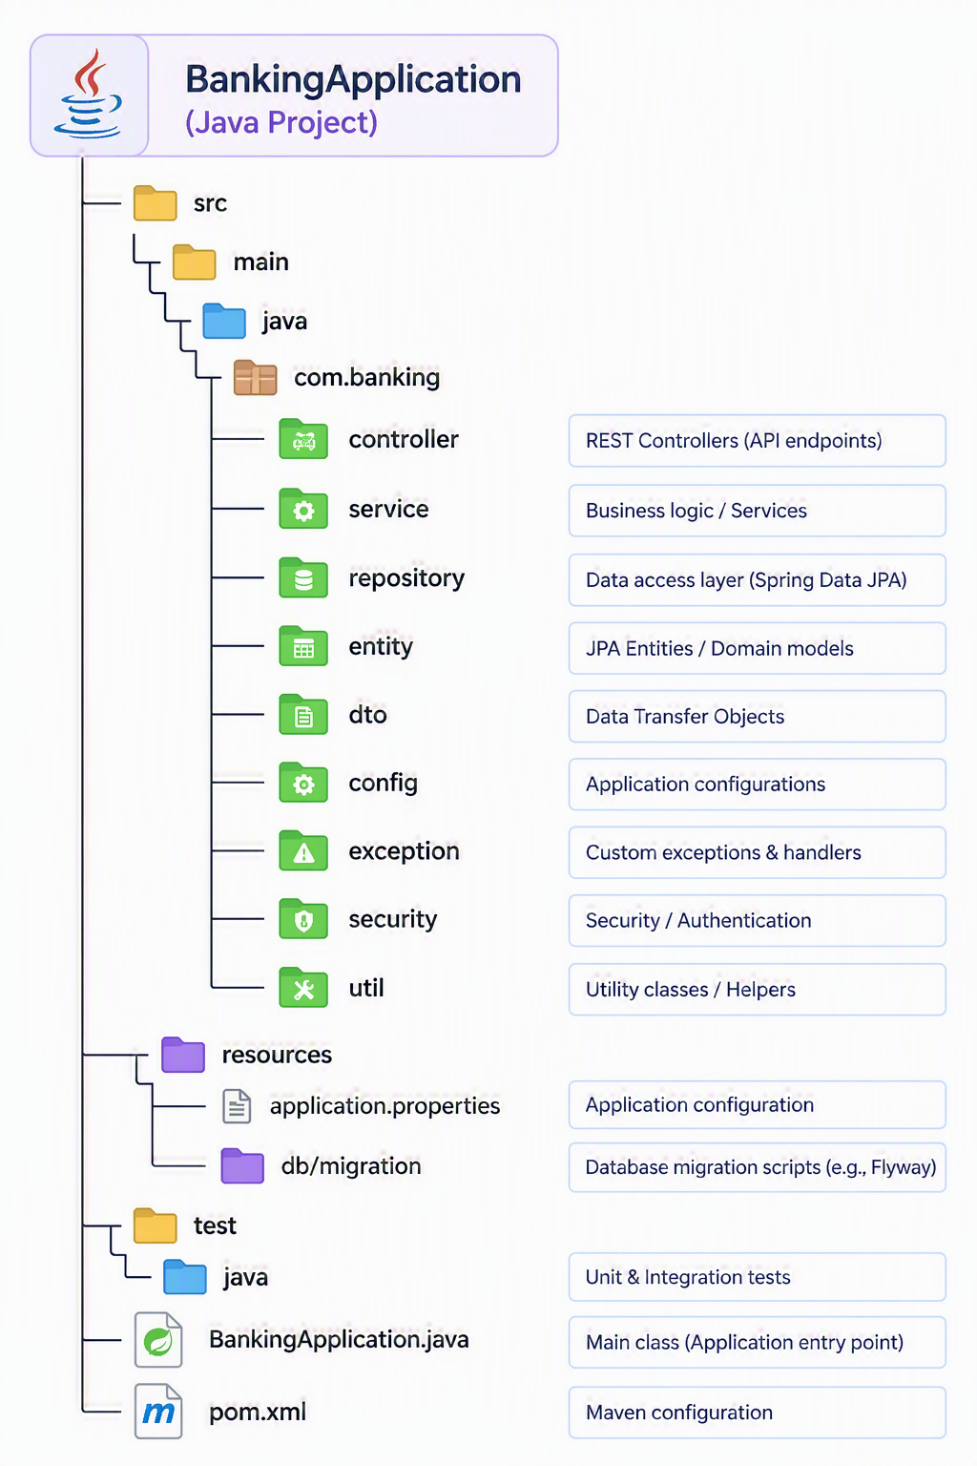

Hands-on:
- Build APIs
- Deploy to Azure App Service
- Understanding App Service Plans
- Working with Deployment Slots

